ShipBot Specifications

Mechatronic Design 2017 Spring

Version: 1.7

## Professor:

John M. Dolan ([jmd@cs.cmu.edu](mailto:jmd@cs.cmu.edu))

## TAs:

Abhijit Chilukuri [achiluku@andrew.cmu.edu](mailto:achiluku@andrew.cmu.edu)

Chiyu Dong [chiyud@andrew.cmu.edu](mailto:chiyud@andrew.cmu.edu)

Judy Han [judyh@andrew.cmu.edu](mailto:judyh@andrew.cmu.edu)

Yichu Jin [yichuj@andrew.cmu.edu](mailto:yichuj@andrew.cmu.edu)

Astha Keshan [akeshan@andrew.cmu.edu](mailto:akeshan@andrew.cmu.edu)

Brigitte Quirk [baq@andrew.cmu.edu](mailto:baq@andrew.cmu.edu)

# Note

The specifications described in this document supersede all previous specifications from lectures and other documents. If you are confused or in doubt about anything, contact the instructors.

Revision log

V1.0 🡪 28 Jan 2017: Initial release.

V1.1 🡪 11 Feb 2017:

Added Abhijit as TA.

Added (revised) size spec.

Added height of Guide Rail.

V1.2 🡪 19 Feb 2017:

Added colored marking, single-revolution restriction to rotary valve handles.

Added painting breaker switches a different color from black.

Added +/-20° tolerance for rotary valves.

Added definition of “visited” in the Final System Demonstration scoring.

Replaced “run” and “demonstration run” terminology with “mission”.

Revamped penalties:

Damage 🡪 2-point penalty vs. zero for the mission.

No penalty for leaving the testbed area.

1-point penalty for each manual intervention.

V1.3 🡪 23 Feb 2017

Added that vertical or horizontal valve configuration will not be provided in the mission file.

Added that exerting large breaker switch force in one direction will not be required.

Added that device height will be ~18” and device depth ~6”.

V1.4 🡪 4 Mar 2017

Changed “percentage open” to “an angular position” for continuous devices.

Made clear that orientation will not be provided in the mission file.

Added that there will be three breaker switches in each breaker box.

Modified time requirement to take into account multiple devices (i.e., breaker switches) at a single station (i.e., a breaker box).

V1.5 🡪 15 Mar 2017

Added that rotary valves can be turned in either direction.

Added that the (larger) wheel valve will only be in a vertical configuration.

Added that desired breaker switch states will be up/down, not on/off.

V1.6 🡪 31 Mar 2017

Added mission file specification.

Added testbed mechanical drawings.

Added 3D printer drawings for handles for large rotary and shuttlecock valves.

V1.7 🡪 14 Apr 2017

Changed the max of 5 devices in mission file to max of 5 stations.

Added pictures of the shuttlecock valves.

Modified competition rules.

V1.8 🡪 23 Apr 2017

Fixed error in mission file specs

# Goal

The goal of this project is to build a mechatronic device capable of operating existing human-operated electro-mechanical devices such that those devices do not have to be modified and retain the ability to be human-operated.

This project, sponsored by Leidos, is inspired by the need to retrofit maritime autonomy onto existing ships that have multiple auxiliary systems, each containing numerous electro-mechanical devices, that must be managed by autonomy while deployed, but still fully accessible and operational by humans when appropriate. The ultimate value proposition of the approach taken for this project would be to offer a more economical and less invasive alternative to replacing hundreds of fully manual-operated electro-mechanical devices with automated ones.

# General Project Requirements

## Form

The device must be portable (to enable testing). It must operate within the testbed described below. Its size should not exceed 1.5’ (width) x 1.5’ (depth) x 2.5’ (height)

## Power

You may use wall power but must use a dedicated supply (such as a PC power supply or wall wart) for the final product. Use of batteries is another possibility for greater mobility. Teams are permitted to use a power tether. You may not rely upon the laboratory bench power supplies to run your device.

## Cost

A guideline reimbursable limit for the total parts and materials cost purchased by the team is about $1000. At the end of the semester, the instructors keep all parts supplied or reimbursed. These will be available for students in succeeding years.

## Construction and Aesthetics

The device must be robustly constructed: use nuts and bolts, machine screws, cable ties, proper soldering, etc., rather than provisional methods. No prototype kits or toys may be used. Appearance counts. “Rat’s nest” wiring, duct tape, bubble gum, or otherwise rickety-looking devices are discouraged not only for lack of aesthetics, but also because they tend to be less robust.

## Safety

The machine must not damage anything with which it interacts. Please prioritize safety when building and testing your device.

## Special Restrictions

This list is not all-inclusive and can be expanded at the discretion of the instructors. The spirit of the course is to build fully embedded systems, and the expectation is that all design components could be reasonably used in a permanent, portable device. Teams therefore may not use a laptop in the final machine (although they are welcome to use them for testing/debugging purposes). A cell phone or webcam may be used, so long as it remains a part of the machine throughout the course. We do not want someone simply taking their primary cell phone out of their pocket every time they come to lab to use in their machine.

# Specific Project Requirements

# Setup

The robot will use the testbed described below as a workspace. A 1-minute period will be allowed for attachment and localization/calibration of the robot. Placement or attachment of the robot will be done at any arbitrary start position on the test bed. The student team is responsible for initial placement of the robot. The robot may then localize/calibrate itself for the mission, for example, by using some part of the testbed as a fiduciary. The robot should carry with it any physical elements required for operation.

No auxiliary equipment or markings, such as lever arms or painted patterns, may be added to the devices or the testbed by the teams. However, the instructors will ensure that each device has sufficient pre-existing features to enable the robot to perceive it and plan how to engage it.

* Valves. In particular, the circular handle of any rotary valves (referred to as “wheel valve” and “spigot valve” in the testbed figure below) will have a painted marking (e.g., a “dot”) of a distinguishing color on its rim, and rotating that marking in either direction to a specified angular position will put the valve into a known state. In addition, though rotary valves can be rotated multiple times, the state will be confined to a single revolution for the purposes of the project. The (smaller) spigot valves may be mounted in one of two possible configurations: vertical or horizontal, where these terms refer to the required plane of rotation of the valve handle. The spigot valve’s configuration must be determined by the ShipBot; it will not be provided in the mission file. The (larger) wheel valve will only be mounted in a vertical configuration.
* Breakers. The breaker switches will be painted with a color that causes them to stand out from the black of the remainder of the breaker device. The large force currently required to move the breaker switches in one of their directions will not be required. Desired breaker switch states will be specified as up or down, rather than on or off, and we will ensure that the smaller force is required for the specified direction.

Prior to the mission, the instructors will set each device in an arbitrary state (e.g., on or off for binary devices or an angular position for continuous devices) that will not be revealed to the team or the robot. Just prior to a given mission, the team will receive a mission file (see Mission File section below) to be uploaded to the robot. The mission file will contain the instructions for the mission in terms of which devices to visit, the desired end state of that device and the target completion time for that mission (set as a function of mission complexity). Once the mission has begun, no human interaction is allowed.

Note that no intrinsic sensory feedback from a device is available (i.e., no instrumentation), so the current state of a device is not known *a priori* (since a human could have made changes between visits by the robot). However, it can be assumed that the physical location of the device with respect to the testbed is fixed and known. The physical location will be given in the mission file as a station designator, where a “station” is one of the eight 1’-wide around the edge of the testbed described below. Breaker boxes will always be vertically oriented. Valves may be vertically or horizontally oriented, and this information will not be provided in the mission file. Designs that enable the robot to determine the current state of the device before taking action are encouraged but not required.

Early in the semester, teams will be provided with instances of each device that will be included in the testbed.

The testbed will include a Guide Rail adjacent to the installed devices. The robot is allowed to physically attach to it (either by the team or by itself as part of the setup time) or it can sense it and use it for (free-form) mobility guidance.

# Mission File

The testbed has eight stations whose Cartesian coordinates your team may have pre-stored. Stations are coded A through H (see Fig. 3).

There are 4 types of devices:

  a. These have codes assigned to them:

* Gate Valve: V1
* Large Valve: V2
* Shuttlecock Valve: V3
* Breakers: B1, B2, B3
  + There are two breaker boxes: Box A has the ‘ON’ position at the top, and Box B has the ‘ON’ position at the bottom. The letter of the box (A or B) will be indicated after the station letter. On both boxes, it is easier to flip the switches from ‘ON’ to ‘OFF’. The mission will only ever ask you to switch a breaker in the “easy” direction.
  + Each breaker box has 3 breakers in the same configuration (one DS, two SS) labeled B1, B2, B3  from left to right.

  b. Each type of valve has an indicator for actuation:

* V1 and V2 will include a desired angle from 0-360 degrees, measured clockwise from vertical, or from the position farthest from the rail if valve is mounted horizontally (i.e. 3 o’clock is 90 degrees)
* V3 includes a desired position (open or closed), designated by 0=open and 1=closed
* B1, B2, B3, if mentioned in the file, must be switched to the ‘off’ position

   c. An example file: “AV1 175, CA B2, DV3 0, FB B3, GV1 50, 360” indicating:

* Turn gate valve at station A to 175 degrees
* Breaker box A is at station C: ensure the second switch is off
* Ensure shuttlecock valve at station D is open
* Breaker box B is at station F: ensure the third switch off
* Turn gate valve at station G to 50 degrees
* The target completion time is 360 seconds

      Another example: “BV3 1, CB B1, CB B2, EA B1, FV2 60, 330”

* Ensure shuttlecock valve at station B is closed
* Breaker box B is at station C: ensure the first switch is off
* Breaker box B is at station C: ensure the second switch is off
* Breaker box A is at station E: ensure the first switch is off
* Turn gate valve at station F to 60 degrees
* The target completion time is 330 seconds

Notes: The stations in the file will always be presented in alphabetical order, in the exact format presented above. The target completion time will always be the last value in the file. The text will be saved as one line in a .txt file delivered to the team on a flash drive.

# Performance Specifications

1. Robots must be able to visit each assigned device and manipulate it to the requested end state within the target mission completion time. For rotary valves, the acceptable error for the end state is +/- 20°. (NOTE: a device may already be in the requested end state.)
2. Robots must be able to traverse the testbed to visit the assigned devices using one of the methods discussed under Setup without leaving the testbed platform area.
3. There should be no damage caused to any device.
4. During the inspection period, all devices should be in the end state prescribed by the mission file (including no touch or attempt to change devices that were not assigned for a visit).

### Coolness Factors

Teams must implement a “coolness factor” – something that goes beyond the basic design requirements and sets your machine apart from other teams. There are many possible coolness factors, including:

* Achieving mission completion faster than the specification
* Providing increased mobility independence
* Accepting multiple missions in a single mission file
* Adjusting the order in which devices are visited to improve mission performance (mainly for even more coolness of free-form mobility designs)

Any coolness factors that you intend to develop and implement should be discussed with the instructors in reports and team meetings and identified at the final lab demonstration.

# Testbed

A schematic of the testbed is shown in Figure 1 and Figure 2. It is designed to test partially or totally ready designs on a real platform. The testbed platform will have eight 1’-wide stations around the edge of the 3’x5’ operating area in each of which a device may be placed. At each station, a device will be rigidly mounted such that the component or components which the ShipBot needs to manipulate will be at a height of roughly 18”+/-2” and a depth (i.e., distance from the guide rail) of roughly 6”+/-2”. The devices will be a variety of valves and circuit breaker switches for the robot to visit and manipulate. There will also be a rigid guide rail along the edge of the operating area. There will be three breaker switches arranged in the same way in each breaker box: two single switches and one double switch.

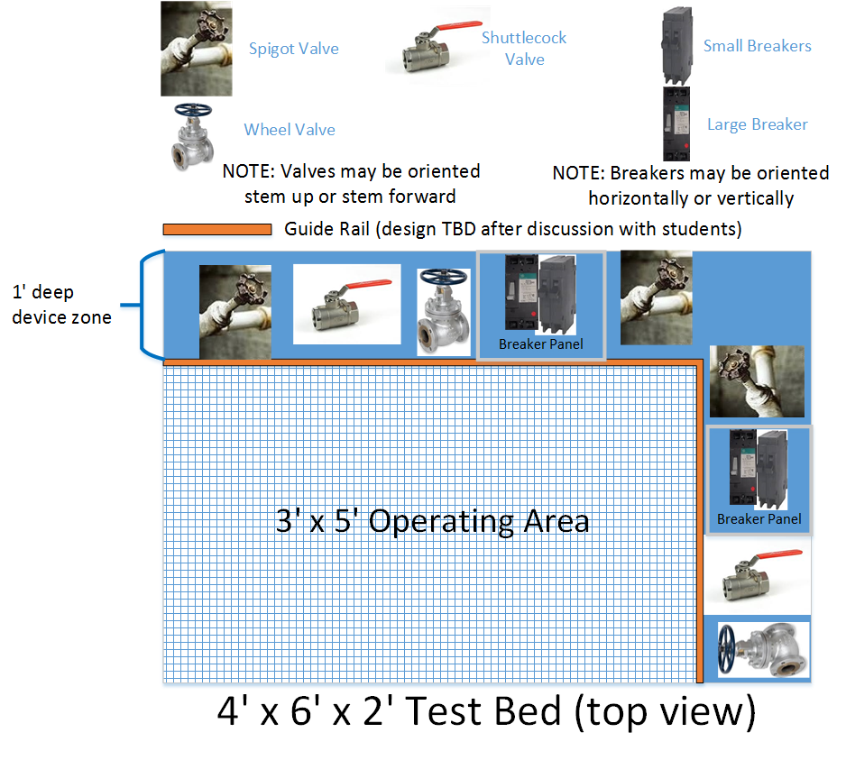

Figure 1. Testbed Schematic Diagram (top view)

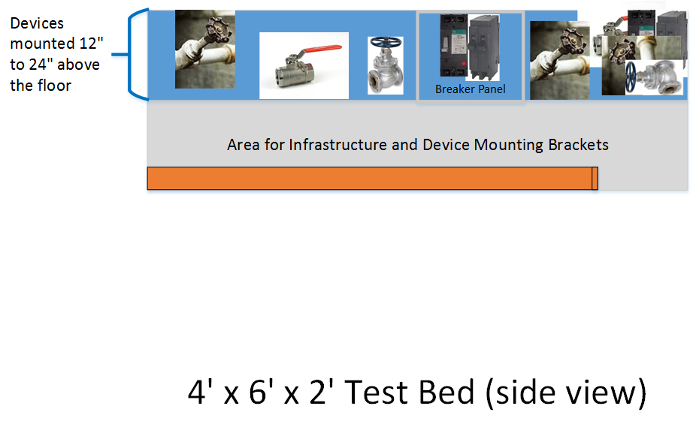

**Figure 2 Testbed Schematic Diagram (side view)**

The entire workspace is 6’ wide x 4’ deep x 2’ high; permission is granted to have robot assemblies extend into the free space immediately surrounding the testbed platform out to 18” as long as the mobility assembly (e.g., wheels, tracks, legs) remains within the Operating Area.

Engineering drawings of the finalized testbed construction are given in Figure 3 and Figure 4.

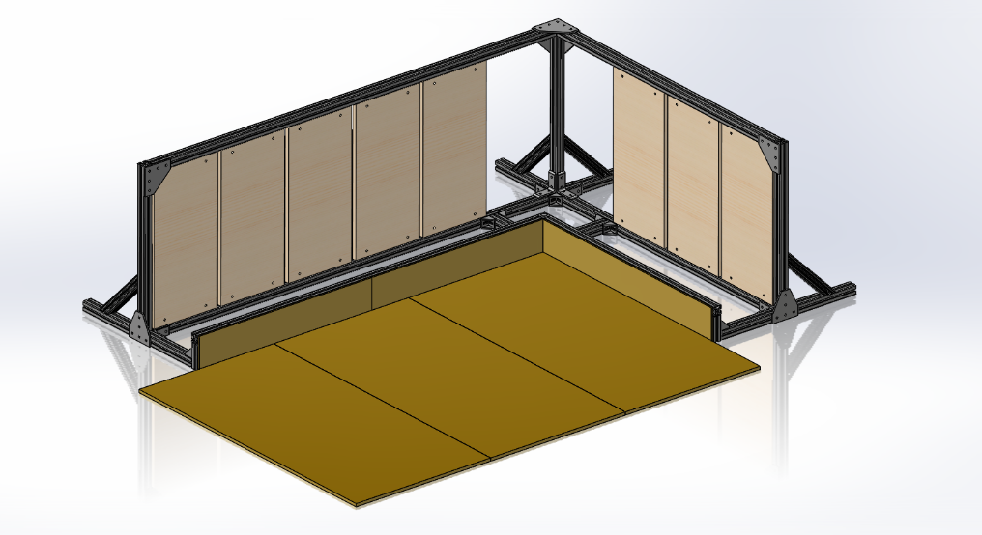

Station H

Station A

Figure 3. Testbed Full Assembly View

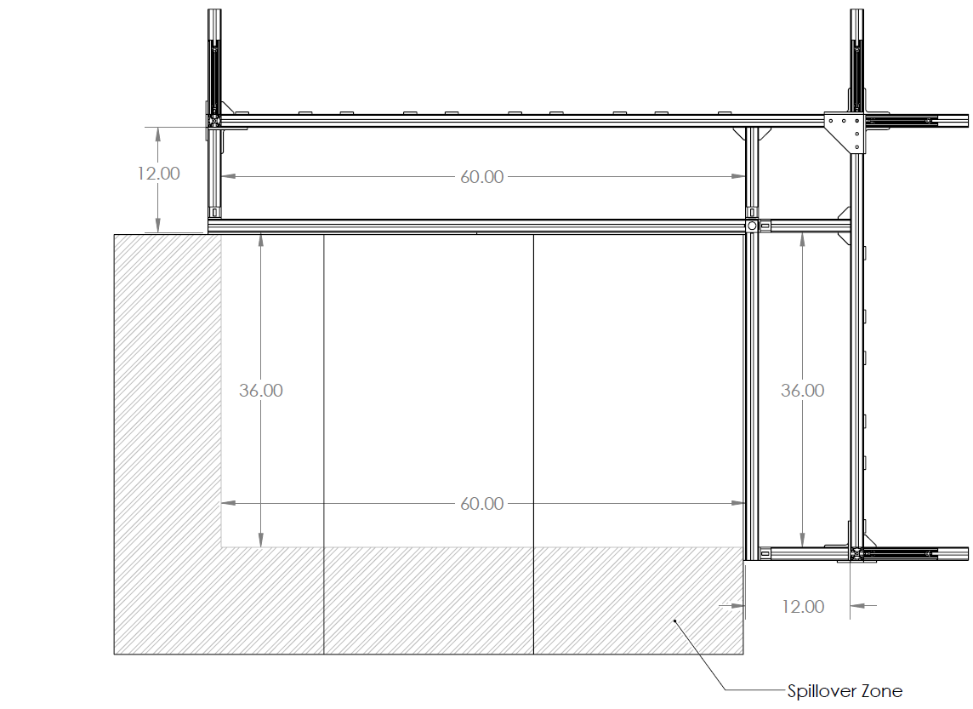

**Figure 4a. Testbed Engineering Drawing (Top View)**

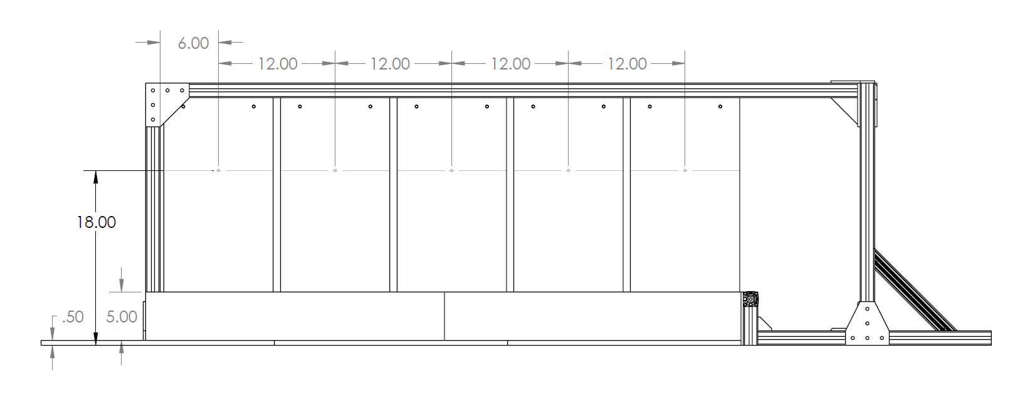

**Figure 4b. Testbed Engineering Drawing (Front View)**

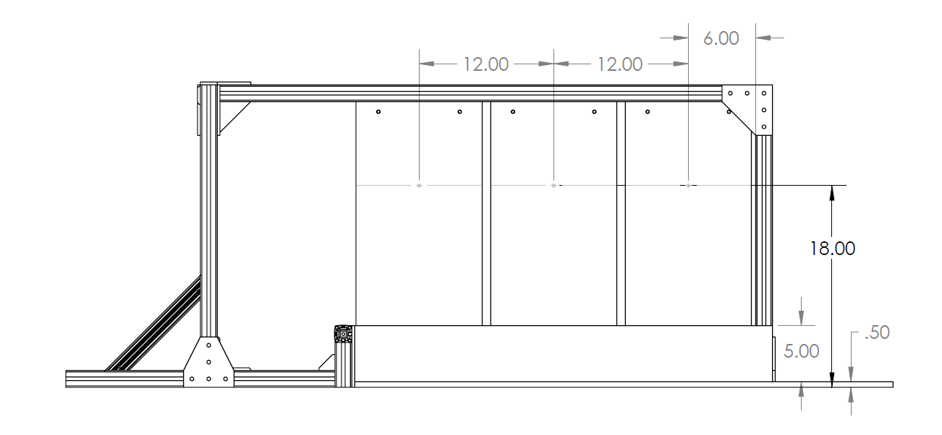

Figure 4c. Testbed Engineering Drawing (Left View)

Figure 5 and Figure 6 show the engineering drawings for the 3D-printed larger rotary valve and shuttlecock valve handles.

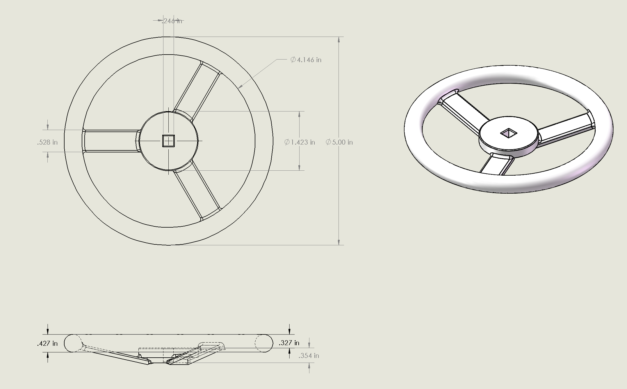

Figure 5. 3D-printed Larger Rotary Valve Drawing

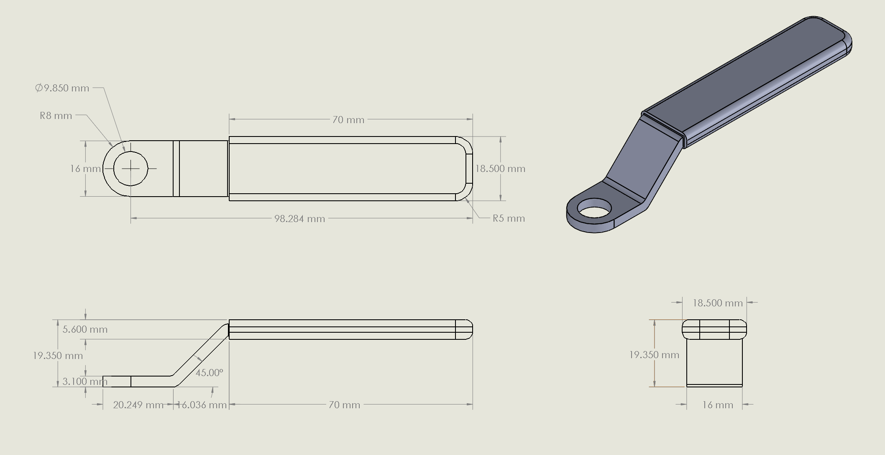

Figure 6. 3D-printed Shuttlecock Valve Handle Drawing

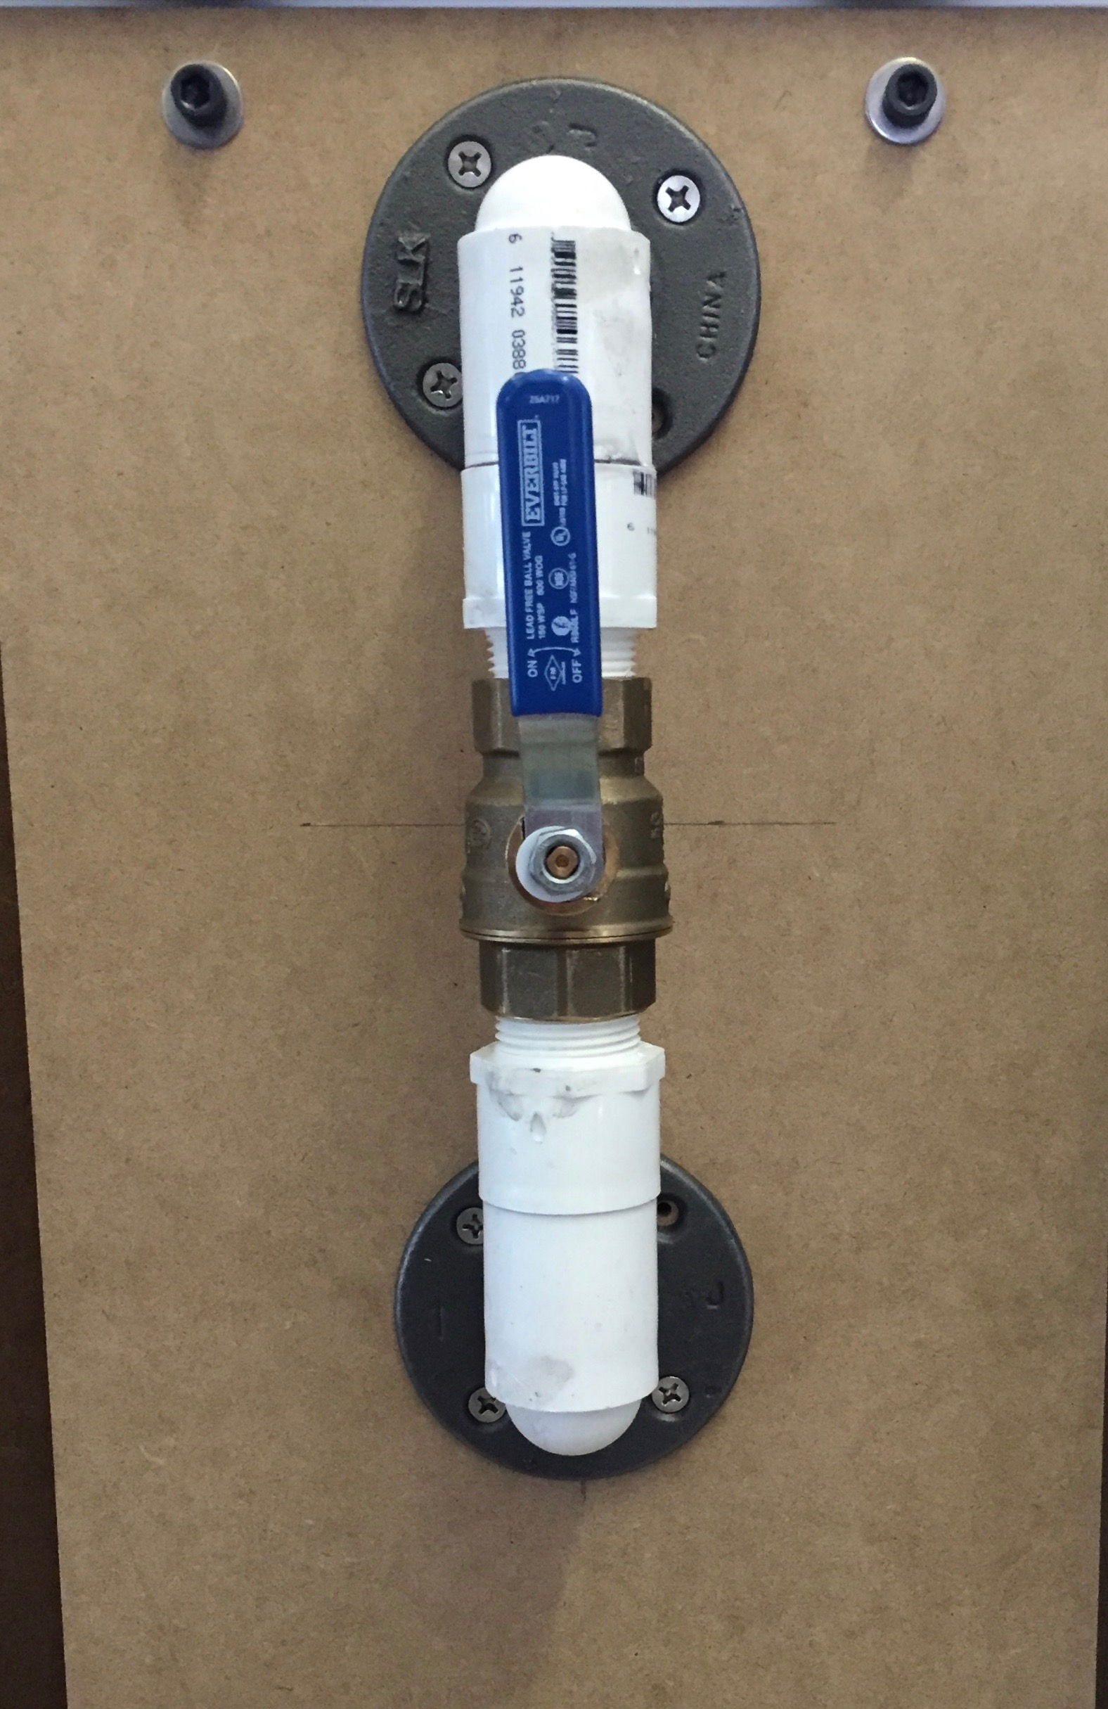 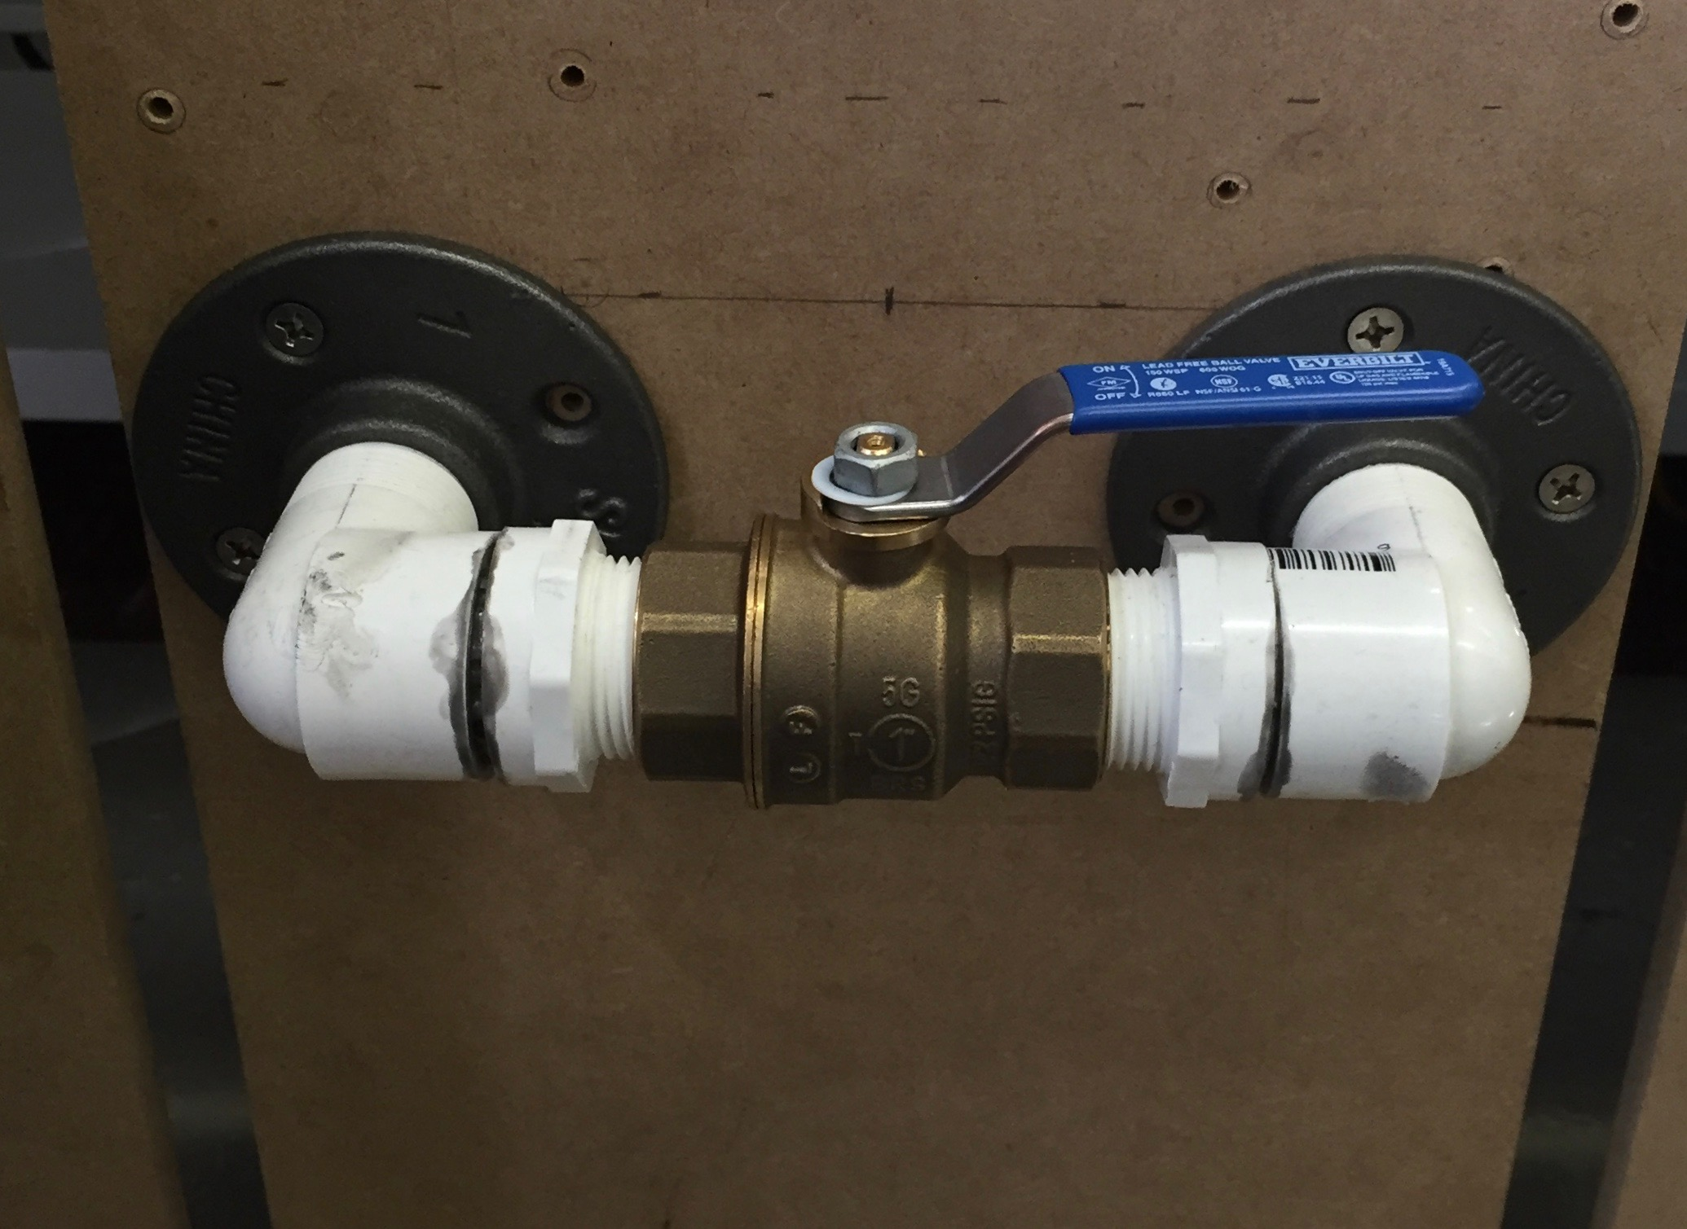

**Figures 7-8. Fixed shuttlecock valve orientations. Both valves are pictured in the “open” position. The “closed” position is a 90 degree clockwise rotation from the position pictured.**

# Performance Evaluation

There will be a final system demonstration and a public presentation. The instructors will determine, evolve and share use cases that further define the types and complexity of missions that will be provided for the final demonstration. The final demonstration will be graded, while the public presentation will provide an opportunity for teams to show off their work and earn extra credit by competing with other teams.

## Final System Demonstration

For the final system demonstration, teams must show how well their machines meet, or exceed, the requirements described above under “Performance Specifications”.

### Place & Time

The final system demonstration and encore take place respectively on April 26 and May 3 in or around the HH 1307 lab.

### Procedure

1. The instructors will set the devices to the appropriate states.
2. The instructors will provide a matching mission file to the team.
3. The team will place its robot according to the setup instructions given above.
4. The team will start its robot using a switch or similar method, and time will start.
5. The robot will conduct its assigned mission without manual intervention. The robot should be able to indicate when it is finished and stop at that point.
6. Time will be stopped when the robot is finished, or when the time period has exceeded the sum of the permitted runtime and the extra runtime.
7. The instructors will score the degree of success using the criteria listed below.

### Success Assessment

* Number of stations and runtime
  + A mission will require servicing of up to 5 stations.
  + Total runtime will be calculated as follows:
    - Normal runtime:
      * N x 1 minute where is N is the number of stations that must be visited
      * An additional 30 seconds per device for stations with more than one device (this applies only to breaker boxes, which can have up to three devices, i.e., breaker switches, at one station)
    - Extra runtime: 20 seconds per device
  + Runtime examples
    - 5 devices at 5 stations 🡪 Total runtime = 5 stations x 1 min. + 5 devices x 20 sec. = 6:00 (5:00 normal and 1:00 extra)
    - 5 devices at 4 stations (i.e., a breaker-box station requires setting two devices) -> Total runtime = 4 stations x 1 min. + 1 extra device x 30 sec. + 5 devices x 20 sec. = 5:30 (4:30 normal and 1:00 extra)
    - 6 devices at 2 stations (i.e., two breaker-box stations require setting three devices each) 🡪 Total runtime = 2 stations x 1 min. + 4 extra devices x 30 sec. + 5 devices x 20 sec. = 5:00 (4:00 normal and 1:00 extra)
* Each device will be worth 3 points maximum, broken down as follows:
  + 3 points: visited, in the correct state, and within the target time
  + 2 points: visited and in the correct state, but after exceeding the target time
  + 1 points: visited, but not in the correct state
  + 0 points: not visited at all (even if coincidentally in the correct state)

For scoring purposes, “visited” means that some part of the ShipBot enters the 1’x1’ area in front of the station where the device is mounted.

* Penalties
  + 1 point (per device): for altering the state of a device not on the list provided in the mission file
  + 1 point: for each manual intervention by the team
  + 2 points: for significant damage to anything in the testbed environment (assessed at most once per mission)
* The minimum score per device is zero, so there will not be negative scores
* The scores for all devices will be summed
* A given mission should achieve a minimum of 2 points per device

### Grading

1-2 points out of the total of 20 will be assigned based on the instructors' qualitative assessment of effort, coolness, and aesthetic and robustness factors.   
  
19-20 pts.: All subsystems work together successfully. Most or all project specifications are met. Coolness factor(s) successfully implemented.  
17-18 pts.: All subsystems work together, but with some glitches that require minor manual intervention. All subsystems are functional.  
15-16 pts.: Most of the system works, with a possible major glitch. All or all but one of the subsystems are functional.  
13-14 pts.: Some of the system works, with more than one major glitch. Possibly one or two subsystems are not functional.  
11-12 pts.: No ability to perform the system's basic functions is demonstrated successfully. Multiple subsystems are not functional.  
9-10 pts.: No ability to perform the system's basic functions is demonstrated successfully. No subsystems are functional. Effort is shown at attempting to get things working.  
0-8 pts.: Nothing working; little attempted.

Penalties will be assessed for deviations from the performance specifications, manual intervention, and demo re-starts.

## Public Presentation and Competition

During the public presentation teams will compete with one another to determine which is best at meeting the performance specifications. This will be based on a combination of correct device settings and speed of task completion.

## Competition Rules

The competition will follow the same procedure as the final system demonstration. Points will be awarded based on the success assessment criteria stated above for the final system demonstration. Ties will be broken on the basis of speed (see Fig. 9).

Deductions will be assessed as follows:

-1 point for every 30 seconds > 1-minute initial setup limit

-0.5 point for each manual intervention

-2 points for each system restart

-3 points for using a benchtop power supply

-3 points for constant manual intervention, such as continuously holding a power tether

## Awards

The two top-scoring teams will receive 10 and 5 extra credit points, respectively, and will share prize money. There will also be extra credit and prize money awards for the following special categories if they are won by teams other than the two top-scoring teams:

* + - 1. Best construction
      2. Fastest (with a minimum average of 2 points per device)
      3. Coolest coolness factor

There will be at least two rounds with all teams competing in each round. The winners will be determined on the basis of total cumulative points.

Figure 9 Winner Decision Algorithm

## Disclaimer

The instructors reserve the right to update the project specifications in order to keep the scope of work within the goals of the course.